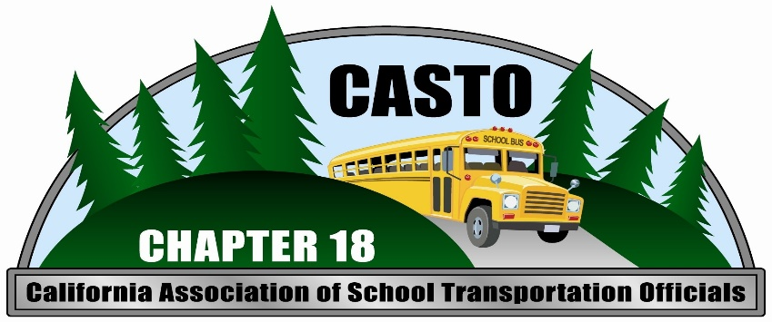
ANNUAL DRIVER
SAFETY WORKSHOP

Date/Time:___________ Location:______________
Tuesday, June 18th 2019 Arcata High School
8:00 a.m. – 3:30 p.m. Fine Arts Building
(Registration at 7:30 a.m.) 1720 M Street, Arcata

General Information:______ Questions:______________
Cost includes: Lunch & CASTO Membership Contact: Anne Avelar
Credit: 5.0 hours of T-01 Credit Phone: (707) 825-2434

Sponsored by CASTO Chapter 18- Humboldt and Del Norte Counties

