CASTO CHAPTER 9
ANNUAL WORKSHOP
Saturday February 1, 2020
6:30 registration
Culinary Arts Facility 1900 Golden Hill Road
7:00am – 1:00pm

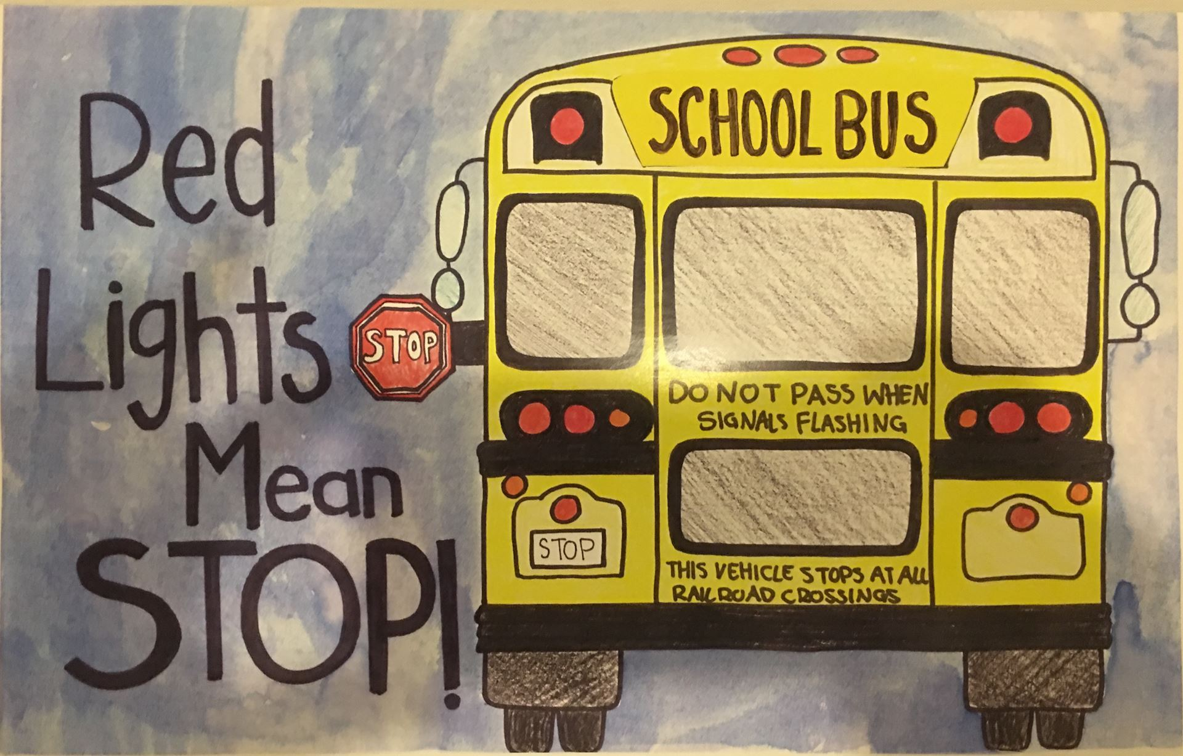
Line up of speakers: 5.0 Hours of TO-1 Time
Al Sauvadon Raffle Prizes
Steve Ventura Continental Breakfast
Karen Wiggington Box Tri Tip Lunch
Amber Gallagher
Dana Budd Members $30.00 Non Members $35.00

